CSA 0509 DBMS
Slot A
Lab Experiment – 4
Updated dept:
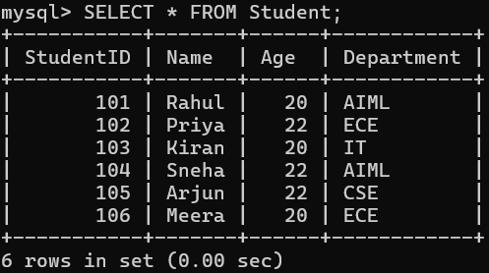
Updated Age:
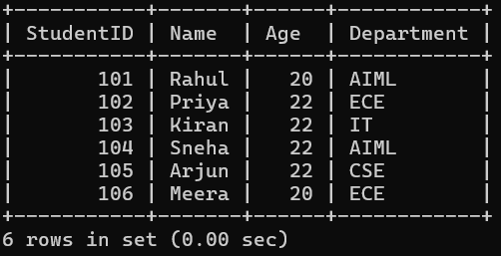
Deleted Student record:
